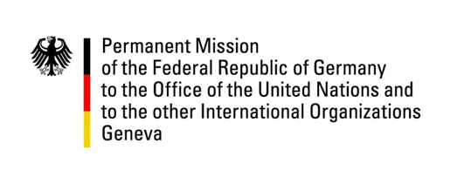

United Nations Human Rights Council
23rd Session of the UPR Working Group

Geneva, 05.11.2015
---
St. Lucia

German National Statement

Thank you, Mr President

Germany commends St. Lucia on its commitment to protect the human rights of children, in particular its ratification of the two Optional Protocols to the Convention on the Rights of the Child, but also its efforts to introduce various bills as part of the Family Law and Domestic Violence Legal and Judicial Reform Project of the Organisation of Eastern Caribbean States.

We are, however, concerned by the fact that consensual sexual activities between adults of the same sex continue to be illegal under the law, even though there seem to have been no convictions in the recent past. It is also unfortunate that St. Lucia has failed to raise public awareness about discrimination against people on the ground of their sexual orientation, despite accepting a recommendation to do so during its last UPR.

Germany would like to make the following recommendations:

One: To ratify core international human rights instruments, including the International Covenant on Civil and Political Rights and its Optional Protocols, the International Covenant on Economic, Social and Cultural Rights and the Convention against Torture and its Optional Protocol.

Two: To introduce legal and practical measures aimed at eliminating discrimination against lesbian, gay, bisexual, transgender and inter-sex persons, including by raising public awareness of the issue, by passing appropriate anti-discrimination legislation and by repealing discriminatory legislation.

Three: To take legal and practical steps to protect women and children from domestic violence, for example by prohibiting corporal punishment of children in all settings, including the home.

Thank you, Mr President

